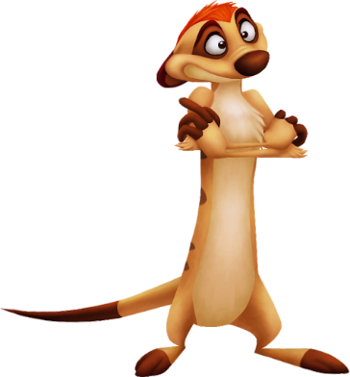

**GAME DESIGN DOCUMENT**

**Jungle Guy**

**Mahyar Mohammadi**

**Game Design Document**

* **Define your own game idea with minimum of 1-3 sentences per point.**
* **Consider the developed game from the viewpoint that you are actually making something which will be published at the .**
* **Focus on the aspects 1-4, others you can define in more general terms since this is only the intro course into game development.**
* **The main aspects you are defining here are the following:**
  + **What would you like your game to look? Search or draw some concept art for your game, levels and characters.**
  + **What is the player doing in the game, what are the abilities of the characters?**
  + **What technological demands or requirements do you have? What technical aspects have to be solved for your idea to work?**
  + **What will your interface look like? What control scheme are you using and how does it work?**

The Jungle guy is a 2D game. The type of the game is side scroller. The player character is staying in just one place during the game and the background moves around the character. The game would be from a side camera. The main character is running and jumping through various levels. The game would be like Mario Bros.

The main character is a fantasy fox or funny character. The game background is a jungle.

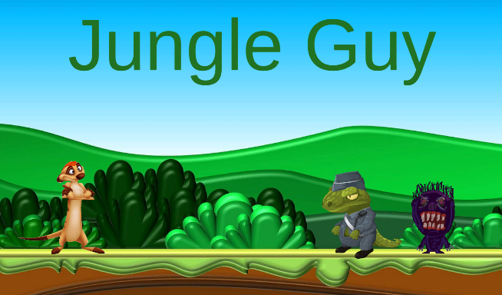

The character runs, jumps, collects the jewels and kicks the enemies .

The game contains several levels.

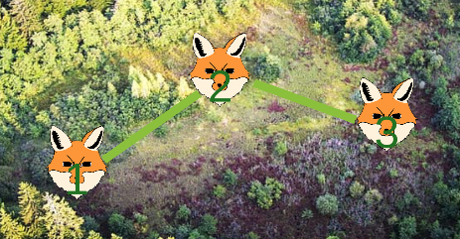

I use Unity 2019.3 for developing the game. The app will be developed for Windows 10.

1. ***Executive Summary, Quick overview***

The game's name is Jungle Guy. It is a 2D game. The type of the game is side scroller. The player character is staying in just one place during the game and the background moves around the character.

1. ***Target Audience***

Suitable for the +3 years gamers.

1. ***Main Characters***

Main character: a funny fox or similar funny character

Enemy 1: funny ghost.

Enemy 2: funny alligator.

***4. Main Features***

*4.1 Main mechanics*

The game would be from a side camera.

*4.2 Movement*

The main character:

1. runs to left and right by A and D,
2. Jumps by space
3. Kicks by W.

*4.3 Physics*

The character can jump higher than normal. The gravity is considered less in the game for more fun.

*4.4 Multiplayer mode*

The game has single-player mode. There is not any multiplayer mode.

1. ***Genre, Setting, Concept Art book\****

The type of the game is side scroller.

***6. Enemies, NPCs, Other objects***

There are two types of enemies.

1. Ghost: It only moves.
2. Alligator: It moves and shoots.

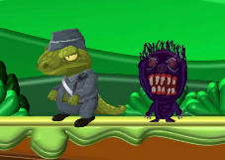

***7. Story board, script\****

*7.1 Story overview*

The character will run and jump and collects the jewels.

There are at least 3 levels in the game.

*7.2 Progression, World 1*

This level contains Ghost as enemies.

*7.3 Progression, World 2*

This level contains Alligator and Ghost enemies.

*7.4 Progression, World 3*

The final level contains Alligator and Ghost enemies. The character jumps over the moving objects.

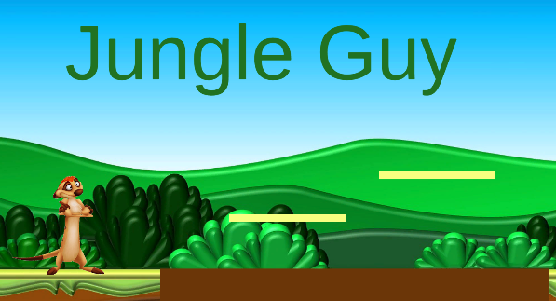

***8. Technical definitions, Tech guide\****

*8.1 Platforms, versions*

Windows 10,

*8.2 Control Scheme*

A: run to left

D: run to right

W: kick

Space: jump

*8.3 Limitations*

The game is not compatible for Mac or phone devices.

***9. Business definitions\****

*9.1 In-app purchases*

The app is free.

*9.2 DLC packs*

There is not any plan for DLC packs yet.

***10. Outsourced/Bought Assets***

Probably I use the free assets for the main character and enemies.

*Topics with (*) usually extended to separate detailed documents, in this project can be simply summarized*